Table of Contents

Yakima Transit

Transit Development Plan

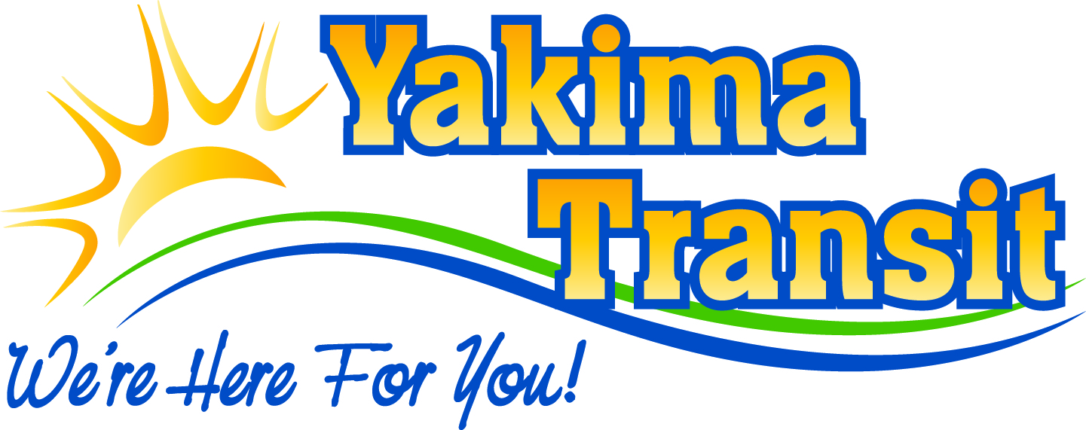

Annual Report for 2021

And

Six-Year Plan 2022-2027
Reported Annually

Adopted by the Yakima City Council: _________________ Resolution _______________
Sec. Title Page
Introduction 3
- Organization 3
- Physical Plant 5
- Transportation Service 5
- Short & Long-Range Public Transportation Operating & Capital Improvement Projects 7
- Community Enhancement Connections 9
- Program Funding 10
- Significant Operating & Capital Changes, 2021-2022 13
- Summary 14
Appendix A: Operating Financial Data, 2021-2022 15
Appendix B: Public Hearing Notice 17
Appendix C: Six-Year Transit Improvement Plan - Project List 18
Appendix D: Service Data by Mode 19
Appendix E: Fixed-Route Map (Yakima) 21
Appendix f: Commuter Map (Ellensburg) 23
Appendix G: Other Service Data by Jurisdiction 24

Acknowledgements

YAKIMA TRANSIT
Alvie Maxey, Transit Manager
Greg Story, Assistant Transit Manager

CITY OF YAKIMA
Scott Schafer, Public Works Director

INTRODUCTION
The Transit Development Plan 2022-2027 and 2021 Annual Report provides updated information to the Washington State Department of Transportation (WSDOT) on development of public transportation components undertaken by Yakima Transit and includes Yakima Transit’s 2021 accomplishments and proposed action strategies for 2022 to 2027. Under RCW § 35.58.2795, Yakima is required to prepare a Six-Year Transit Development Plan and annual report and submit it to WSDOT. WSDOT uses this document to prepare an annual report for the Washington State Legislature summarizing the status of State public transportation systems. The document is also used to notify the public about completed, current, or planned projects. In order for this document to be effective, the Yakima City Council must approve the document following a public hearing.
This plan is required to be updated each year in order for Yakima Transit to fully inform the Federal Transit Administration, Washington State Department of Transportation, Yakima City Council, and the Public of projects that have been undertaken and are planned to be undertaken. Because this is a plan, not every project will be completed when planned in the document and some projects may never be started as a result of changed conditions or other factors.

SECTION I: ORGANIZATION

History
In 1907, the City of Yakima’s public transportation originated with a steel-rail streetcar system. The Yakima Valley Transportation Company operated the first transit service. Motorized buses were introduced in 1924 as a supplement to the rail streetcar routes. The City’s all-electric streetcars were discontinued in 1947 when the services offered switched to an all-motor bus system. In 1957, a private provider began operating the bus system. The private provider discontinued service in 1966 and for four months no public transportation services were operated in the City of Yakima. In the fall of 1966, Yakima citizens voted to approve the State’s first household tax to financially support a public transit system and public transit services were re-established under contract with a private provider. In October 1970, the City purchased the assets of the financially-troubled private provider and continued transit services as a City-owned and operated public transit system. In November 1980, Yakima citizens approved a 0.3% transit sales tax that replaced the City’s household tax as the transit system’s method of financial support. Currently, the Federal Transit Administration classifies Yakima Transit as a small urbanized transit system serving a population between 50,000 and 200,000 people.
Yakima Transit’s services include Fixed-route, Paratransit (Dial-A-Ride), Vanpool, and Commuter bus service between Yakima and Ellensburg. As a result of the American’s with Disabilities Act, Dial-A-Ride services were added in 1992. Vanpool was established in 1998 in order to provide transportation services to workers who travel outside the area to locations like Hanford.
The Yakima-Ellensburg Commuter started at the end of November 2011, to provide transportation services for faculty, staff, and students traveling to either the Yakima Valley Community College or Central Washington University. Those schools account for approximately 70% of Commuter ridership. In June 2014, Yakima Transit took the main partnership role in making sure the program is operated to meet partnership and community needs.

Organizational Structure
The Yakima City Council is ultimately responsible for Yakima Transit’s operations. Several management layers help control Transit activities & programs including the City Manager, Public Works Director, Transit Manager and the Assistant Transit Manager. The City Manager and Public Works Director report back to the City Council on Transit activities and address Transit policies and finances. The Transit Manager oversees the daily operational activities of the Transit System, which is overseen by the Public Works Director and City Manager.
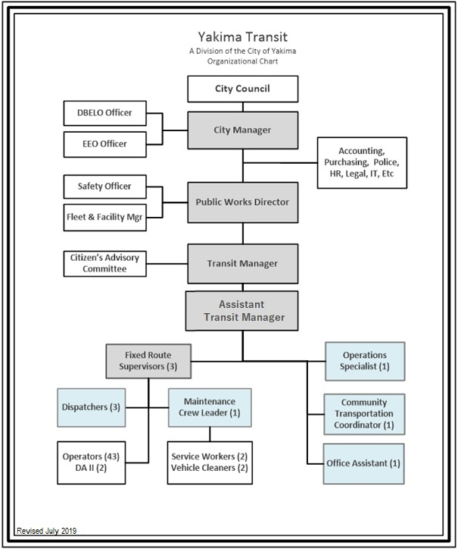
As of December 31, 2021, Yakima Transit directly employed 58.5 employees in Administration, Fixed route, Paratransit, and Vanpool services. Transit staff positions are generally frontline positions.

Yakima Transit pays for various administrative services through the City of Yakima including Legal, Human Resources, Vehicle Maintenance, Purchasing, Information Technology, and Financial Services. Yakima Transit also contracts with private organizations for Paratransit & Commuter services. Medstar, LLC, operates the Dial-A-Ride service and in 2021 employed approximately 38 employees consisting of an Office Manager, Dispatchers, Schedulers, Drivers, Vehicle Cleaners, and Mechanics. In 2021, A&A Motor coach operated the Yakima-Ellensburg Commuter, employing up to eight Drivers, a Supervisor, and a Maintenance person.
Residents can address their Transit concerns directly to the City Council Members during any regularly scheduled Council meeting. The City Council also solicits public comments on transit specific issues during the review and adoption of the City’s annual budget and Transit Development Plan. All City Council meetings and budget review meetings are broadcast live on local television and taped for rebroadcast online for those unable to attend the actual session.
A Citizen’s Advisory Committee meets quarterly and consists of members of the community with an interest in Transit, as well as individuals who use Transit on a daily basis. The group is updated on Yakima Transit’s projects and goals. They are asked to provide input on proposed projects, give public and system user comments on services they would like to see in the system, and comment on future services Yakima Transit could provide. Community participation helps Yakima Transit address passenger concerns.

SECTION II: PHYSICAL PLANT LOCATIONS
Yakima Transit’s administrative and operations offices are located at 2301 Fruitvale Boulevard. Yakima Transit’s Human Resources, Legal, & Financial services are provided by the City of Yakima either at the Public Works Facility, City Hall, or the Legal Center. Yakima Transit has a Transit Center in the Downtown Yakima core at 4th Street and Walnut. Yakima Transit provides three park and ride lots throughout Yakima at the following locations: Yakima Public Works Facility at 2301 Fruitvale Blvd; Chesterly Park at 40th Avenue and Powerhouse Road; and the City of Yakima Information Center at Fair Avenue and Lincoln.

SECTION III: TRANSPORTATION SERVICE

Services
During 2021, Yakima Transit served the City of Yakima with Fixed-Route, Paratransit, Vanpool services, and Commuter ervices to Ellensburg with the Yakima-Ellensburg Commuter. (Maps at Appx E and F) Yakima Transit also promotes sidewalks, pathways, and bicycle routes. Yakima Transit provides the following connections to rail, air, and other fixed-route services: Union Gap Transit, Selah Transit, and the Community Connector (Lower Valley service).
Fixed Route
During 2021, Yakima Transit operated Fixed-route bus service along ten different routes that operate between the hours of 6:00am and 7:00pm within the City of Yakima:
- 10 routes Monday - Friday (6:00am - 7:00pm);
- 10 routes on Saturdays (8:45am - 6:00pm); and,
- 7 routes on Sundays (8:00am-4:00pm).

Weekday routes are operated on one hour and half-hour basis on most routes. Saturday & Sunday routes are operated on an hourly basis. Yakima Transit’s system map, as illustrated in the Appendix E, depicts the 2022 fixed routes. Over the next six years, some routes may be cut, modified, or discontinued to maintain or expand more efficient routes.
Yakima Transit is continuously striving to provide an updated fleet for its passengers. Six diesel powered buses were placed on order in late 2021 with delivery in late 2022 from Gillig. Future buses may potentially consist of electric or other alternative fuels meeting the State of Washington’s alternative fuels regulations, if this is the most feasible option.
Expansion routes outside of Yakima Transit’s jurisdiction require service demand and funding support from either the State, Federal, or local jurisdictions (other than the City of Yakima).

Paratransit (Dial A Ride)
In 2021, Yakima Transit provided paratransit services in the City of Yakima. Dial-A-Ride services were available during the same operating schedule as fixed-route services. Under contract with Medstar, LLC, complementary paratransit services were available to residents, who qualify for service under the provisions of the Americans with Disabilities Act. Paratransit services are provided door-to-door to eligible clients and serves the areas within the city limits of Yakima and some trips into the city of Union Gap and Selah. Contractor costs at the end of 2021 were around $1.45 million for the year in 2021. Yakima Transit does not anticipate any major changes to the paratransit area of operation, except as it relates to any expansion of the fixed-route program and replacing vehicles. Yakima Transit will be exploring and researching the possibility of bringing the Paratransit program in-house in the future instead of having a contracted service.

Vanpool
Yakima Transit operated a Vanpool service for residents of Yakima in 2021. Vanpool services were provided on a full cost recovery basis in normal non-pandemic years; the majority of costs were recovered through fees from the users and the rest was covered by Transit. Yakima Transit’s Vanpool program in 2021 was running on average of 2 vans per month. This program was severely impacted by the COVID-19 pandemic in 2019-2020 and as a result, as of March 2020, all Vanpools had voluntarily ceased operation. In mid-year 2021 there were 2 Vanpools in operation.
The Vanpool program was discontinued completely at the end of December 2021 due to lack of use and inadequate cost recovery leaving the program non-sustainable.

Park & Ride Lots
Yakima Transit provides service to five park & ride lots: Chesterly Park at North 40th Ave and River Road, Gateway Center along Fair Avenue at I-82, the Public Works Facility at N. 23rd Avenue and Fruitvale Boulevard. The Yakima-Ellensburg Commuter utilizes the Firing Center Park & Ride Lot (Selah) and the Park & Ride lot located next to the Selah Civic Center in downtown Selah.

School Service
Yakima Transit provides weekday non-exclusive transportation service to Elementary, Middle, and High Schools. The School Districts do not provide transportation services for students who live within a mile of the school; however, the school district purchases youth passes for the students to use. In 2021, School District passes accounted for 14% of fixed-route fares (total youth fares accounted for 27%). School district passes are not discounted. These routes run along the same route as normal routes and are generally filled up with more than 50-70 students boarding either before or after school. The school runs have the highest ridership per hour of all fixed-route runs and were initially setup because regular route buses were overcrowded making it difficult for other passengers to use the service either before or after school hours.

Multimodal Connections
Yakima Transit provides service to the following public transportation facilities/connections:
- Greyhound Bus Terminal (5th Avenue & Walnut Street)
- Lower/Upper Valley Community Connector (Yakima Transit Center)
- Yakima-Ellensburg Commuter (Yakima Air Terminal, YVCC, and Yakima Transit Center)
- Union Gap Transit & Yakima Airport (Routes 7 & 9)
- Selah Transit (1305 N 16th Avenue and 1206 N 40th Avenue)

Fare Structure
Single-ticket fares & monthly fares were last increased in March 2013. Fares are as follows:
For fixed-route bus service, day passes are still offered at three times the cost of a single fare, or twice the fare for passes obtained after 9:15am. Fixed-route transfers are available for “one free ride” on any bus, on any route, during one of three time periods each day. Morning transfer tickets are valid until 9:15am. Mid-day transfer tickets are honored from 8:45am to 3:15pm and afternoon/evening transfers are effective from 2:45pm until the close of service. The boarding time determines which transfer the passenger receives. Yakima-Ellensburg Commuter transfers to the fixed-route system are free with the purchase of a Commuter ticket.

SECTION IV: SHORT & LONG-RANGE PUBLIC TRANSPORTATION OPERATING & CAPITAL IMPROVEMENT PROJECTS

Local Operating Projects
- Offer regional transit service connections to Kittitas County (Ellensburg/CWU Campus). Yakima Transit continues to operate the Yakima-Ellensburg service under contract. The previous funding cycle ended on 6/30/21, and the current grant cycle runs from 7/01/21 – 6/30/23. When compared to previous years and before the 2020 pandemic, the ridership in 2019 had remained steady with a slight increase in ridership. In 2020 ridership fell by 85%. By mid-way through 2022, this service has almost recovered to 2019 levels. This is partially due to Central Washington University being back in session.
The Commuter bus will begin its route in each city at approximately 6:00 AM and will be arriving to their destination by 7:45 AM.
On average, the Yakima-Ellensburg Commuter provides more passenger trips than each of the four State operated Intercity Transits (Apple, Grape, Gold, & Dungeness Lines) at less than 1/3 of the combined miles travelled and at roughly 1/3 the combined cost.
Grants and partnership funding are required to continue to keep the service operational, with the fare box recovery averaging around 10%.
- Fixed-Route Passenger Counters. In 2019, Yakima Transit purchased new software/IT equipment that assists in collecting data for reporting purposes. Yakima Transit is required to collect and report this data on an annual basis to the State (Washington State Department of Transportation) and Federal (Federal Transit Authority) levels. This new technology was fully implemented by the end of 2019.
- Paratransit Passenger Counters. In late 2023 - mid 2024, Yakima Transit anticipates equipping the paratransit fleet with passenger counter tablets similar to the fixed-route system tablets. Yakima Transit is required to collect and report this data on an annual basis to the State (Washington State Department of Transportation) and Federal (Federal Transit Authority) levels.
- Security Cameras. Bus security cameras were upgraded in 2019, giving Yakima Transit the ability to have live video feed.

Local Capital Projects
- Vehicle Replacement.
  - Buses. All of Yakima Transit’s fixed-route bus fleet are low-floor Gilligs. Six new buses are on order for delivery in late 2022 depending on the ability of the manufacturer time schedule.
  - Vanpool. Most Vanpool vans were either transferred internally within Transit or to other City departments, or sold at auction at the end of the program. No new vans will be purchased unless the program is started again in the future.
  - Commuter. Yakima Transit does not own the vehicles used in the Yakima-Ellensburg Commuter. The vehicles are owned and operated by the service provider, A&A Motorcoach.
  - Dial A Ride. Four new large Transit Vans are being ordered in late 2022 for delivery in later 2024. New vehicles will be ordered every year in the next 6 years depending on funding.
  - Administrative. Four new Administrative vehicles may need to be ordered in 2023 or 2024 depending on use. One Vanpool Transit van was transferred to Service Work instead of going to auction.
- Continue to maintain/improve ADA amenities within the transit system. Yakima Transit continues its efforts to maintain and improve ADA access within the system. Yakima Transit plans to:
- Purchase ADA accessible vehicles with ramps.
- Work with the City Streets, Planning, and Engineering Departments to identify and partially fund sidewalks installation throughout the Transit system to help individuals with mobility issues get to the bus stop.
- New Transit Base of Operations. Yakima Transit purchased 506 W Fruitvale Blvd in July 2022 for a new Transit Base of Operations in Yakima. Anticipated move in is 2025 as the property is being leased back to the former owners as they build a new facility. The new Transit location will house Yakima Transit Administrative offices, vehicles, low maintenance garage, cleaning bay, ticket booth, etc. The new Transit location is also anticipated to help Yakima Transit switch over to alternative fuels, if they are feasible. At some point in the future, Yakima Transit anticipates all the buses will have alternative fuel sources.
- Build a new Westside Transfer location. Yakima Transit anticipates building a new Transfer station in west Yakima/West Valley within the next 6-10 years. This Transfer Station will not only offer improved services to the west Yakima and West Valley community, but it will support the Transit Center currently located in east Yakima, offering more efficient routes and connectivity throughout our entire system.
Capital improvements over the next six years will depend on transit sales tax. If sales tax revenues decline, planned projects may be put on hold until revenue is available to do the project. Planned capital investments are listed in Appendix C. Major improvements planned include: vehicle replacement, fixed-route passenger shelters, bus stop improvements, and technology improvements.

SECTION V: COMMUNITY ENHANCEMENT CONNECTIONS
Throughout the City of Yakima, there are several planned or completed community enhancement projects. This section provides updates on transit connectivity to those programs/developments.
Yakima Transit provides bus service to several annual community events including fare-free shuttle services to: the Central Washington State Fair, the City of Yakima’s Fourth of July Fireworks Show, and the Arboretum’s Christmas Luminaria Event. All of the transit services provided are open to the general public.
The following are important City of Yakima community enhancement projects that are planned:
YMCA Aquatics Center - The YMCA Aquatics Center is a year-round aquatics center located at the City of Yakima’s Chesterly Park (40th Avenue and River Road). Yakima Transit has several routes that serve this facility. At peak service, there are six buses per hour (66 buses per day) that serve the facility.
Sozo Sports Complex (SOZO) – SOZO is a sports facility, located at the south central area of the City of Yakima in a relatively rural area just west of the Yakima Airport. The SOZO complex combines both indoor and outdoor fields and courts for soccer, basketball, football, and other sports. Transit services to SOZO are anticipated in the near future since the streets leading to and from the complex were completed in 2022. Service may commence in spring 2023.

SECTION VI: PROGRAM FUNDING

FINANCIAL FORECAST
Financial forecasting primarily pulls from past service levels, anticipated needs, and market trends. This analysis consists of Yakima Transit’s projected revenue and expenses for maintaining efficient service levels, while still being able to maintain an active vehicle fleet. The long-term strategies adequately address capital vehicle replacement and operations. On average, total capital and operating expenses are around $10M annually. The projected Ending Cash Balance, includes anticipated capital investments.

Revenues
The information contained in this section breaks down revenue streams and considers the outlook of those revenue sources. Operating revenue consists mainly of local sales tax and grant funding. Revenue is also obtained from farebox, monthly bus passes, tickets, and reimbursements from other jurisdictions served.
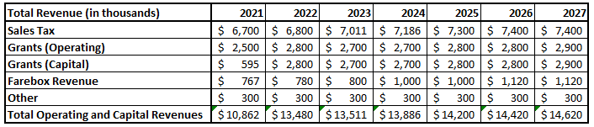

Sales Taxes
Yakima Transit utilizes a three tenths of one percent (0.3%) sales tax that was passed by voters in 1980. Sales tax revenue accounts for approximately 52% of total transit revenue in 2021. Sales tax revenues typically remains relatively consistent year to year with a slight fluctuation either up or down. Each one tenth of one percent equates to approximately $1.96M in revenue per year.

Farebox Revenue
Farebox revenue is one of the smaller funding parts to operating public transportation. Farebox revenue consists of Fixed-route, Dial-A-Ride, and Commuter funds. Passenger fares play an important role in funding transit services. A balance between the cost of the service and what a passenger is willing to pay must be maintained to ensure that users participate in the cost of providing the service. If the cost of the fare is too high, individuals who could drive may opt for the convenience of driving.
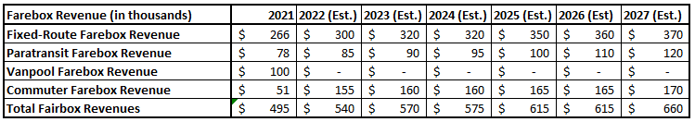
For 2021, farebox revenue accounted for 16% of all revenue. Yakima Transit ridership fell again over the last year due to the pandemic, with a count of approximately 470,000 passengers served.

Grant Funds
Yakima Transit utilizes both federal and state grants, which in 2021, accounted for approximately 36% of total revenue. State and Federal funding has remained at or near prior year levels. Federal formula allocations have continued to increase.
Operating grants consist of the annual operating grant (apportionment), operating grants for ADA paratransit services (apportionment), and the Yakima-Ellensburg Commuter (discretionary).
Grants include the following Projects:
2020 CARES ACT Grant
In April of 2020 Yakima Transit received from the Federal Government $6,268,035 in emergency CARES Act funding. These funds were supplied to provide emergency relief during the Covid-19 Pandemic that started in February of 2020. These funds are intended to make up for shortfalls in public transits budgets due to loss in revenue and loss in ticket sales. This money can be used in a variety of ways to keep Yakima Transit operating. As of August 2021-2022, these funds are being used to pay for Personnel Protection Equipment (PPE) for drivers and office staff. The funds have also been used to install barriers in the fixed route fleet to protect drivers from direct exposure. Planned expenditures of this grant are to pay for any shortages, Paratransit, PPE, and any other costs over the next 4 years. This grant is non-renewable.

2021-2023 – Yakima-Ellensburg Commuter
Yakima-Ellensburg Commuter – Yakima Transit receives funding from the State of Washington Department of Transportation for commuter bus service between Yakima and Ellensburg. This grant is on a two-year cycle (July 2021 – June 2023 currently). Because it is a discretionary grant, the grant may not be awarded and the service would likely stop operating. The service is done in partnership with the City of Selah, City of Ellensburg, and Central Washington University. Without partnership support, Yakima Transit would not be able to provide the service. The grant covers about 35% of the service, local funds account for approximately 48% of the cost, and the farebox revenue accounts for the remaining 17%.
Cost: $1.0M Grant: $490K Status: Currently being used.

2021-2023 – Paratransit Special Needs Formula Grant
Paratransit Special Needs Formula Funds (PTSNF) - Yakima Transit receives an apportionment (roughly $240K every two years) from the Washington State Department of Transportation for paratransit services. Yakima Transit spends approximately $1.5M every year on paratransit services.
Cost: $3M Grant: $240K Status: Currently being used.

2021 – 5307 Small Urban Operating Assistance
Annual Grant - Yakima Transit receives FTA 5307 funding totaling approximately $2.3M annually. This grant is essential to maintain existing fixed-route bus services.
Cost: $4.6M Grant: $2.3M Status: Currently being used.

Operating Expenditures
Yakima Transit’s total operating expenses for 2021 were $9.3M, a $400K decrease from 2020. Major operating expenses include fuel, labor, insurance, and other costs. Employee costs were the primary factor for the increase along with technology upgrades. For 2022, operating expenses are anticipated to be steadily increasing.
Yakima Transit operates fixed-route, paratransit, and commuter bus service. These modes of transportation are addressed by their overall cost to the budget including operating and capital costs.
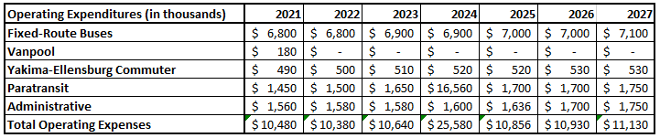

Fixed-Route
Yakima Transit spends most of its funds on the fixed-route bus service. In years in which buses are not purchased, the largest part of the cost is wages and benefits, accounting for nearly 70% of the total cost to provide the service. Maintenance (16%) and significantly increased fuel costs (7%) make up the next two highest expenses, with the rest being insurance, supplies, and equipment upgrades. In the chart above, fixed-route costs fluctuate because of the vehicle replacement program. In March 2017, Yakima Transit purchased four new transit buses, as part of Transit’s ongoing bus replacement plan. Six bus purchases are on order with delivery date of late 2022.

Dial-A-Ride
Yakima Transit operates fixed-route bus services, which requires (by federal law) the Transit system to operate complementary paratransit services (Dial-A-Ride) to disabled individuals who cannot ride the fixed-route bus system. Currently, Medstar operates Dial-A-Ride under a contract with Yakima Transit. The farebox-recovery ratio for this service is usually around 5% in 2021. Yakima Transit leases vehicles to Medstar to help control maintenance costs and provide funds for replacement vehicles.

Vanpool
The Vanpool program is similar to carpooling, except that the passengers are using a transit vehicle. Yakima Transit pays for fuel, insurance, and maintenance. Each passenger is charged a monthly fee based on miles driven and the type of vehicle. Three Vanpool vehicles were ordered as replacements in 2017. With the program shut down at the end of 2021, no new vehicles will be purchased and administrative expenditures will drop to zero.

Yakima-Ellensburg Commuter
Yakima Transit contracts with A&A Motorcoach to provide this service. The farebox-recovery ratio for this service is usually at 17%. The City of Ellensburg and City of Selah participate in the Commuter service. In 2018, Yakima Transit provided an additional round-trip run on a trial-basis in the mornings, but due to a lack of ridership this run was discontinued.

Capital Funds
Yakima Transit sets aside $800,000 to $1,000,000 annually in the capital reserve account for major capital projects like vehicle and facility replacement/expansion, as well as other smaller capital improvement projects. When revenue exceeds actual costs, those additional funds are put into a reserve account for either capital or operating. With proposed capital facility improvements over the next six years, the amount set aside will need to continue in order to complete the anticipated projects. Most of the time, grant funding is used for a portion of capital projects, primarily to replace vehicles.

General Forecast
In the general forecast, the next several years show high expenditures as a result of vehicle replacement. Replacing vehicles are balanced out with the reserve account (ending cash balance) ensuring that Yakima Transit is financially healthy while upgrading the fleet.
Yakima Transit’s ideal vehicle replacement schedule is at a rate of 1.5 fixed-route buses and 3 paratransit vehicles each year. This schedule may grow or wane as money allows. With the changes to the system, there is enough money in the capital budget to allow for these purchases. Buses typically cost $550K, Dial-A-Ride vehicles $75K vans and large passenger ADA equipped vans $85K.
A general financial forecast is shown in Appendix A.

SECTION VII: SIGNIFICANT OPERATING & CAPITAL CHANGES, 2022 – 2027
Other than vehicle replacement and equipment upgrades, Yakima Transit does not have any significant operating changes planned for 2022-2027. Major projects are listed in the six-year transit improvement plan – project list, Appendix C. Maps of the current system are shown in Appendix E-G.
There have been several changes and upgrades in 2019, including upgrading the modems, cameras, and bus computers, adding live video streaming capabilities to assist supervisors, dispatchers, and the Yakima Police Department.

VIII. Summary
Overall, Yakima Transit’s revenues and expenses are stable. Capital projects that have been delayed year after year are anticipated to be an option in the coming years. Services are anticipated to be more flexible so Yakima Transit can more fully serve the public.

APPENDIX A: OPERATING FINANCIAL DATA - 2021 Annual - & Budget 2022-2027
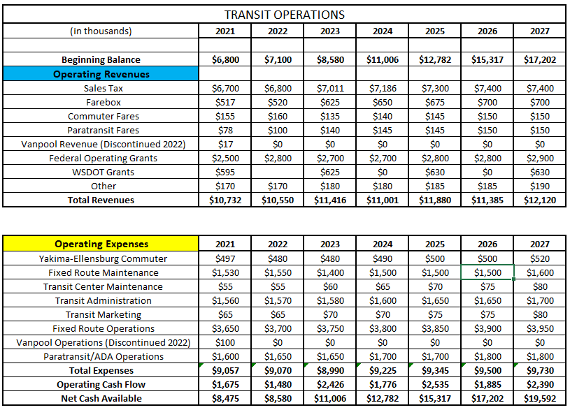

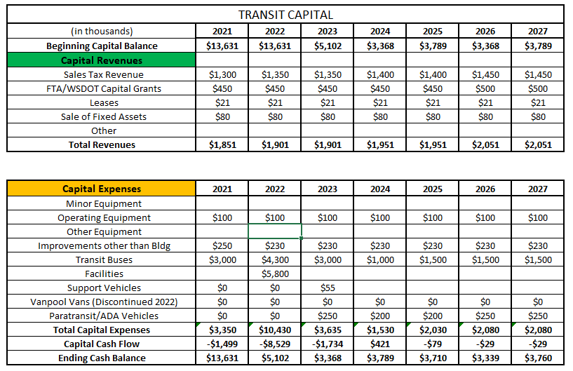

APPENDIX B: PUBLIC HEARING NOTICE

Friday, June 17, 2022

Yakima Transit is submitting to the Washington State Department of Transportation its Six-Year Transit Development Plan and Annual Report.
These documents address state and local long & short-range priorities, capital improvements, planned significant operating changes and, program funding sources for the following six years, and the summary of Yakima Transit’s 2021 operations.
Public notice of public involvement activities and time established for public review of and comments on the TIP will satisfy POP requirements.
A public hearing on the submittal will be held Wednesday, July 20, 2022, at 5:30pm at Public Works, 2301 Fruitvale Blvd., Yakima, WA 98902. The meeting can also be attended via Zoom conference call. To join meeting, call (253) 215 8782 or (971) 247 1195, the meeting ID is 916 4751 7228 and the passcode is 222338.
A draft document and additional meeting information including the link to join the meeting online will be available at www.yakimatransit.org on July 6, 2022.
Final approval of the program is anticipated to go to the Yakima City Council on Tuesday, August 16, 2022.

APPENDIX C: SIX-YEAR TRANSIT IMPROVEMENT PLAN - PROJECT LIST

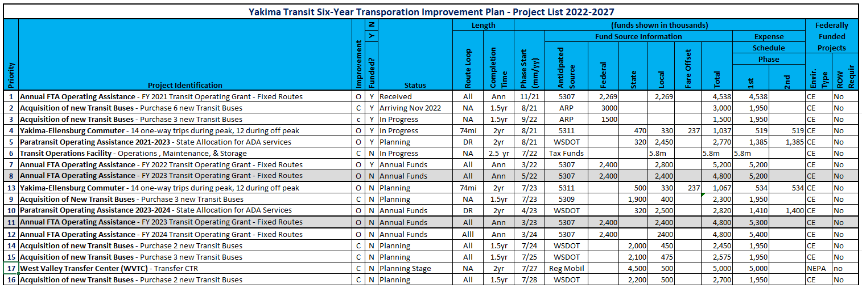

APPENDIX D: SERVICE DATA BY MODE

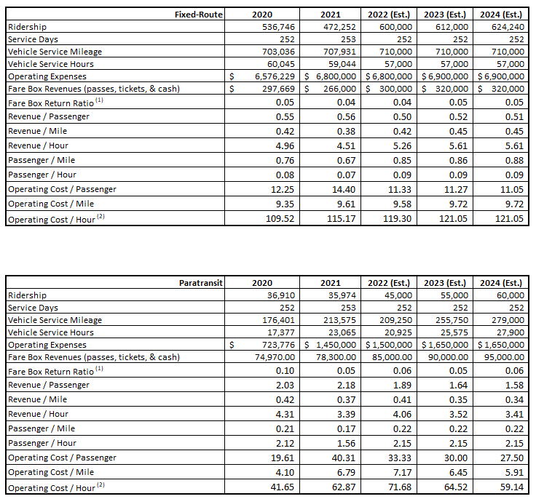

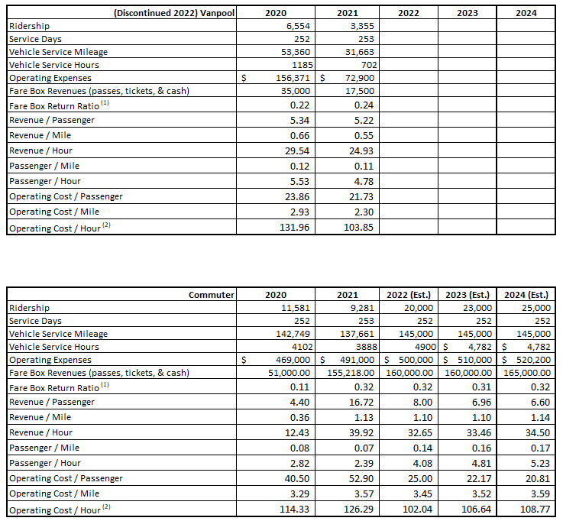

APPENDIX E: FIXED-ROUTE MAP (Yakima)
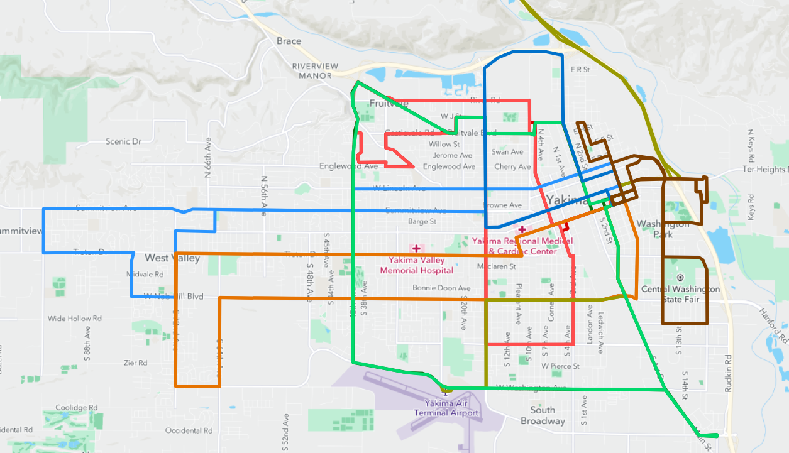
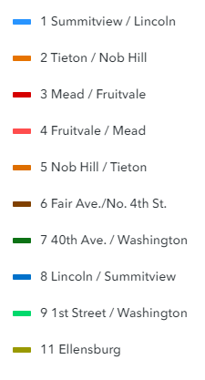

APPENDIX F: COMMUTER MAP (Ellensburg)
